**NEPAL COLLEGE OF INFORMATION TECHNOLOGY**

**Balkumari, Lalitpur**



**A Lab Report**

**On**

**Subject:- Web Technology**

**Lab Report # _2__.**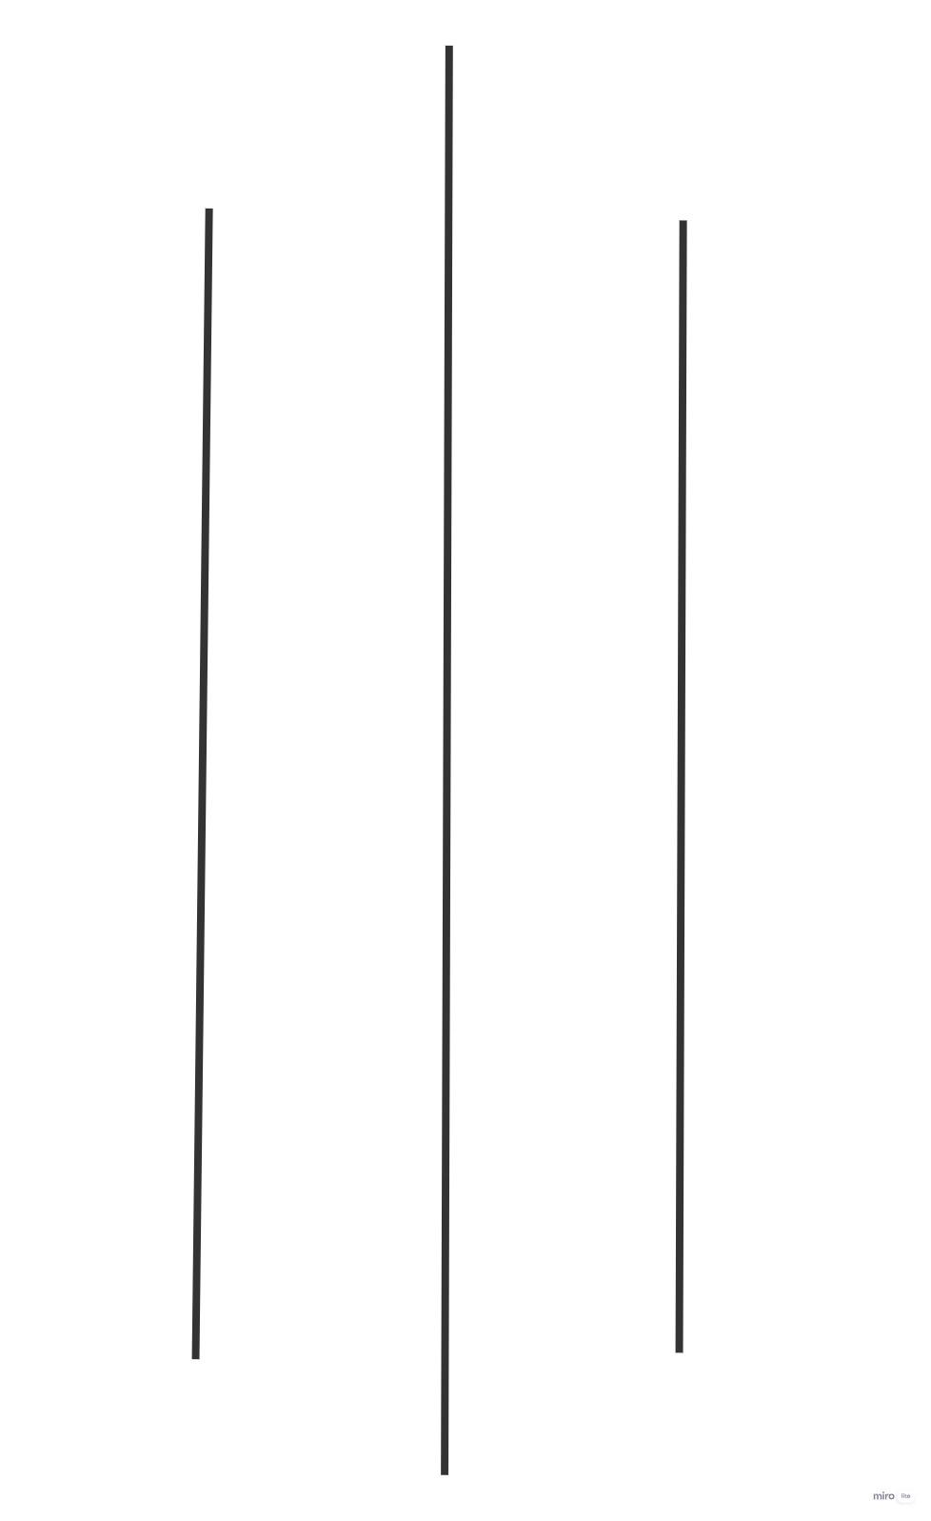

**Title: - HTML list,image,hyperlink.**

**Submitted by:- Submitted to:-**

**Name : - Abiral Chaudhary Instructor: - Simanta Kasaju**

**Roll No:- 221702 Department :- software**

**Faculty: - science and technology Submission Date:2080/**

**Semester:-II**

**Question:1**

**code:<!DOCTYPE html>**

**<html lang="en">**

**<head>**

**<title>Question 1 </title>**

**</head>**

**<body>**

**<h1>List Example</h1>**

**<ol>**

**<li>List Item 1</li>**

**<ol type="A">**

**<li>Neste item 1.1</li>**

**<li>Nested item 1.2</li>**

**</ol>**

**<li>List Item 2</li>**

**<ol type="i">**

**<li>Nested item 2.1</li>**

**<li>Nested item 2.2</li>**

**<ul type="square">**

**<li>Nested item 2.2.1</li>**

**<li>Nested item 2.2.2</li>**

**<ul type="circle">**

**<li>Nested item 2.2.2.1</li>**

**<li>Nested item 2.2.2.2</li>**

**</ul>**

**<li>Nested item 2.2.3</li>**

**</ul>**

**<li>Nested item 2.3</li>**

**</ol>**

**<li>List Item 3**

**<ul type="disc">**

**<li>Item 1</li>**

**<li>Item 2</li>**

**<li>Item 3</li>**

**</ul>**

**</li>**

**</ol>**

**<Pre>COMP 376**

**Introduction to Game Programming</Pre>**

**<pre>Soen287**

**Web Programming</pre>**

**<p>This is a <sup>9</sup>test<sub>5</sub> for assignment 1</p>**

**</body>**

**</html>**

**Screenshot:**

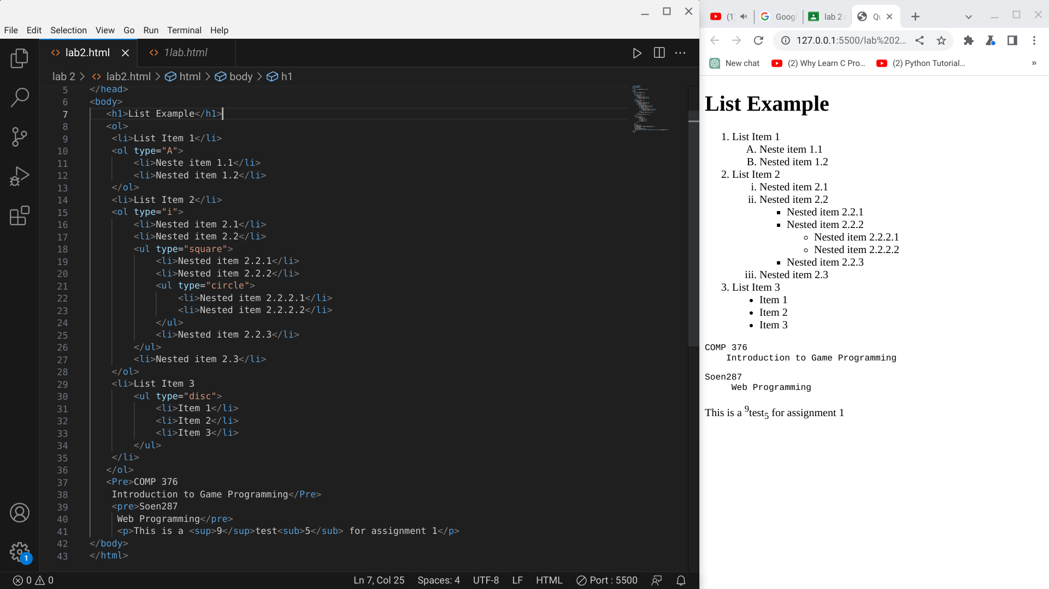

**Question:2**

**code:<!DOCTYPE html>**

**<html lang="en">**

**<head>**

**<title>Question 2</title>**

**</head>**

**<body>**

**<h1>Learning Web Development</h1>**

**<ol type="I">**

**<li>Background Skills</li>**

**<ol type="A">**

**<li>Unix Commands</li>**

**<li>Vim Text Editor</li>**

**</ol>**

**<li>HTML</li>**

**<ol type="A">**

**<li>Minimal page</li>**

**<li>Headings</li>**

**<li>Tags</li>**

**<li>Lists</li>**

**<ol type="i">**

**<li>Unordered</li>**

**<li>Ordered</li>**

**<li>Definition</li>**

**<li>Nested</li>**

**</ol>**

**<li>Links</li>**

**<ol type="i">**

**<li>Absolute</li>**

**<li>Relative</li>**

**</ol>**

**<li>Images</li>**

**</ol>**

**<li>CSS</li>**

**<ol type="A">**

**<li>Anatomy</li>**

**<li>Basic Selectors</li>**

**<ol type="i">**

**<li>Element</li>**

**<li>Class</li>**

**<li>ID</li>**

**<li>Group</li>**

**</ol>**

**<li>The DOM</li>**

**<li>Advanced Selectors</li>**

**<li>Box Model</li>**

**</ol>**

**<li>Programming</li>**

**<ol type="A"><li>Python</li>**

**<li>JavaScript</li></ol>**

**<li>Database</li>**

**<ol type="A">**

**<li>Flat File</li>**

**<li>Relational</li>**

**</ol>**

**</ol>**

**</body>**

**</html>**

**Screenshot:**

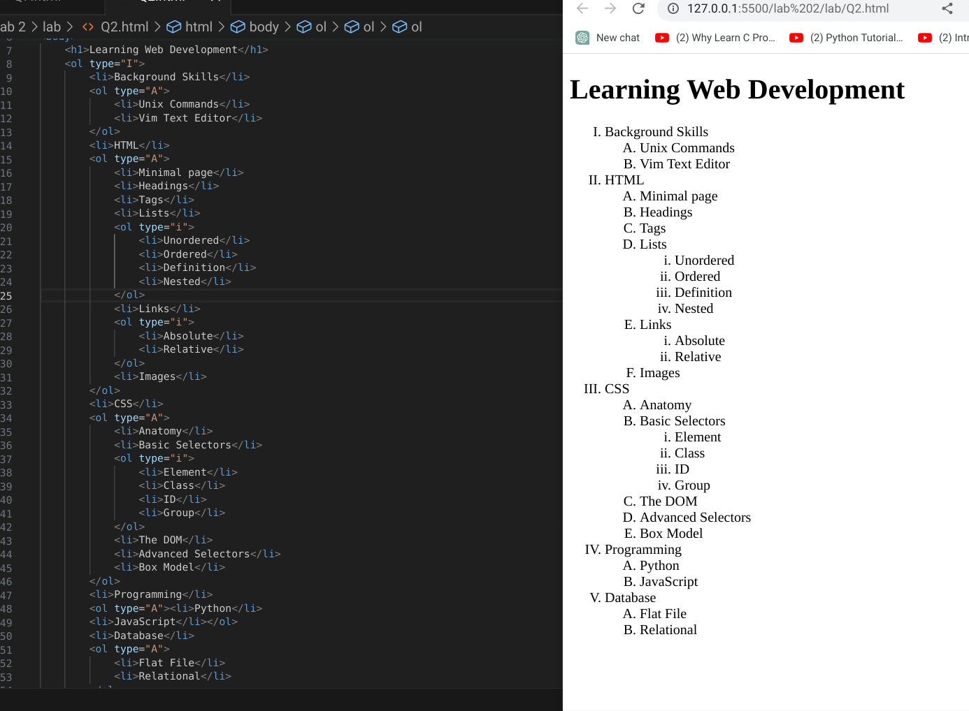

**Question:3**

**Code:**

**<!DOCTYPE html>**

**<html lang="en">**

**<head>**

**<title>Document</title>**

**</head>**

**<body>**

**<style>**

**.box {**

**width: 700px;**

**height: 550px;**

**border: 1px solid #333;**

**}**

**</style>**

**<div class="box">**

**<h2><centre>Types of Memory in a Computer</centre></h2>**

**<ol type="1">**

**<li>Primary Memory</li>**

**<ol type="a">**

**<li>RAM</li>**

**<li>ROM</li>**

**<ol type="i">**

**<li>PROM</li>**

**<li>EPROM</li>**

**<ul type="disc">**

**<li>UVEPROM</li>**

**<li>EEPROM</li>**

**</ul>**

**</ol>**

**</ol>**

**<li>Secondary Memory</li>**

**<ol type="a">**

**<li>Magnetic Disk</li>**

**<ul type="disc">**

**<li>Hard Disk Drive</li>**

**<li>Floppy Disk</li>**

**</ul>**

**<li>Magnetic Tape</li>**

**</ol>**

**</ol>**

**<h3>FULL FORM</h3>**

**<dl>**

**<dt>RAM</dt>**

**<dd>Random Access memory</dd>**

**<dt>ROM</dt>**

**<dd>Read only memory</dd>**

**<dt>PROM</dt>**

**<dd>Programmable read only memory</dd>**

**<dt>EPROM</dt>**

**<dd>Erasable programmable read only memory</dd>**

**<dt>EEPROM</dt>**

**<dd>Electrically erasable programmable read only memory</dd>**

**</dl>**

**</div>**

**</body>**

**</html>**

**Screenshot:**

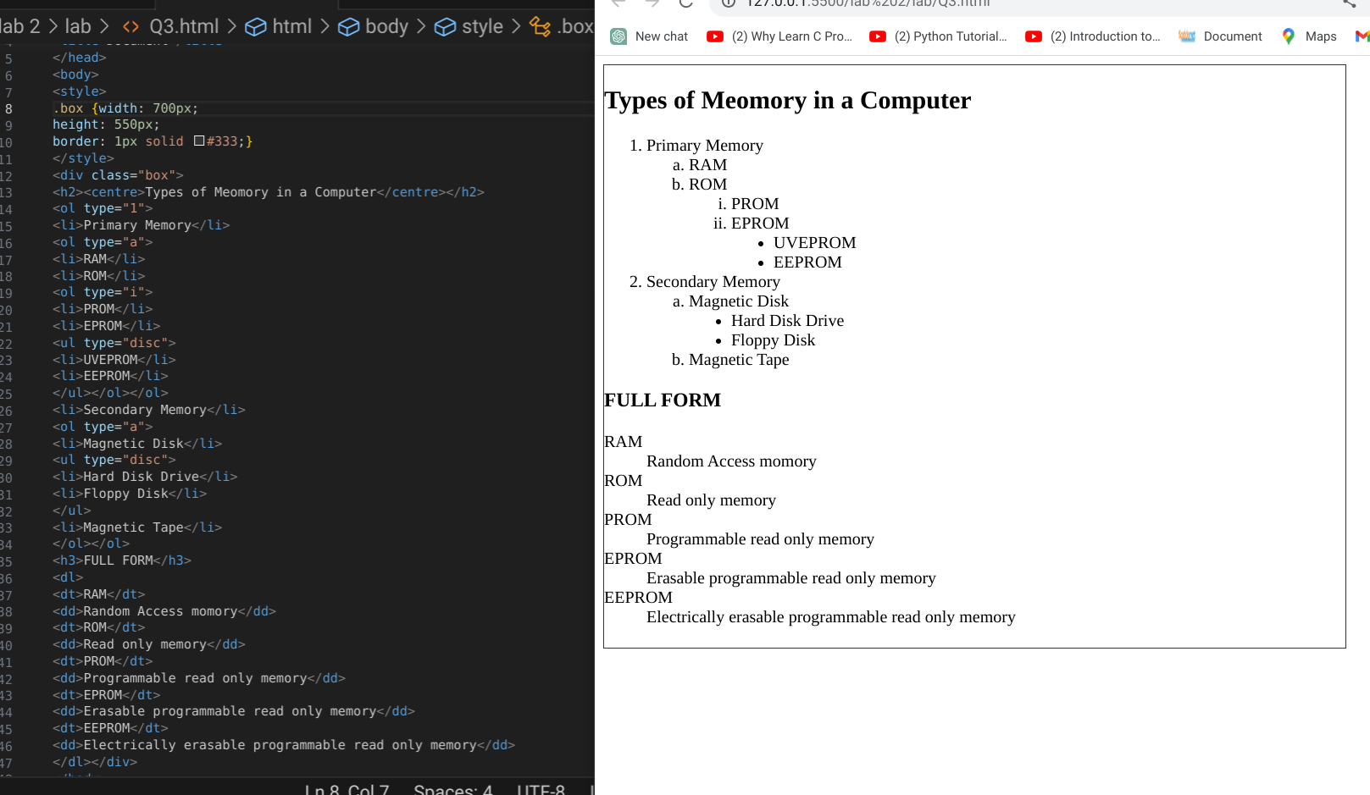

**Question:4**

**code:<!DOCTYPE html>**

**<html lang="en">**

**<head>**

**<title>Document</title>**

**</head>**

**<body style="background-color: aqua;">**

**<h1 style="text-align: centre;">My personal Details</h1>**

**<a href="#personal">personal section</a>**

**<a href="#academic">academic section</a>**

**<a href="#contact">contact section</a>**

**<a href="gallery.html">My gallery</a>**

**<hr>**

**<h2 id="personal">Personal info</h2>**

**<p>Name:Abiral Chaudhary</p>**

**<p>DOB: 2003</p>**

**<p>Age: 19</p>**

**<p>Gender: Male</p>**

**<p>Marital status: abcd</p>**

**<p>Nationality: Nepali</p>**

**<a href="https://www.youtube.com/results?search_query=simanta+kasaju"><img src="2.avif"**

**alt="2.avif" height="200px" width="100px" title="Youtube"></a>**

**<hr>**

**<h2 id="academic">Academic</h2>**

**<p>SLC: 2.95</p>**

**<p>+2: 3.54</p>**

**<p>Bachelor: running </p>**

**<p>Masters : N/A</p>**

**<hr>**

**<h2 id="contact">Contact</h2>**

**<p>email: abiralchaudhari0987@gmail.com</p>**

**<a href="mailto:abiralchaudhari0987@gmail.com">Mail to me</a>**

**<p>Phone: 9800000000</p>**

**<p>Address: bhaktapur, thimi</p>**

**<p>POB: 892</p>**

**<hr>**

**</body>**

**</html>**

**Screenshot:**

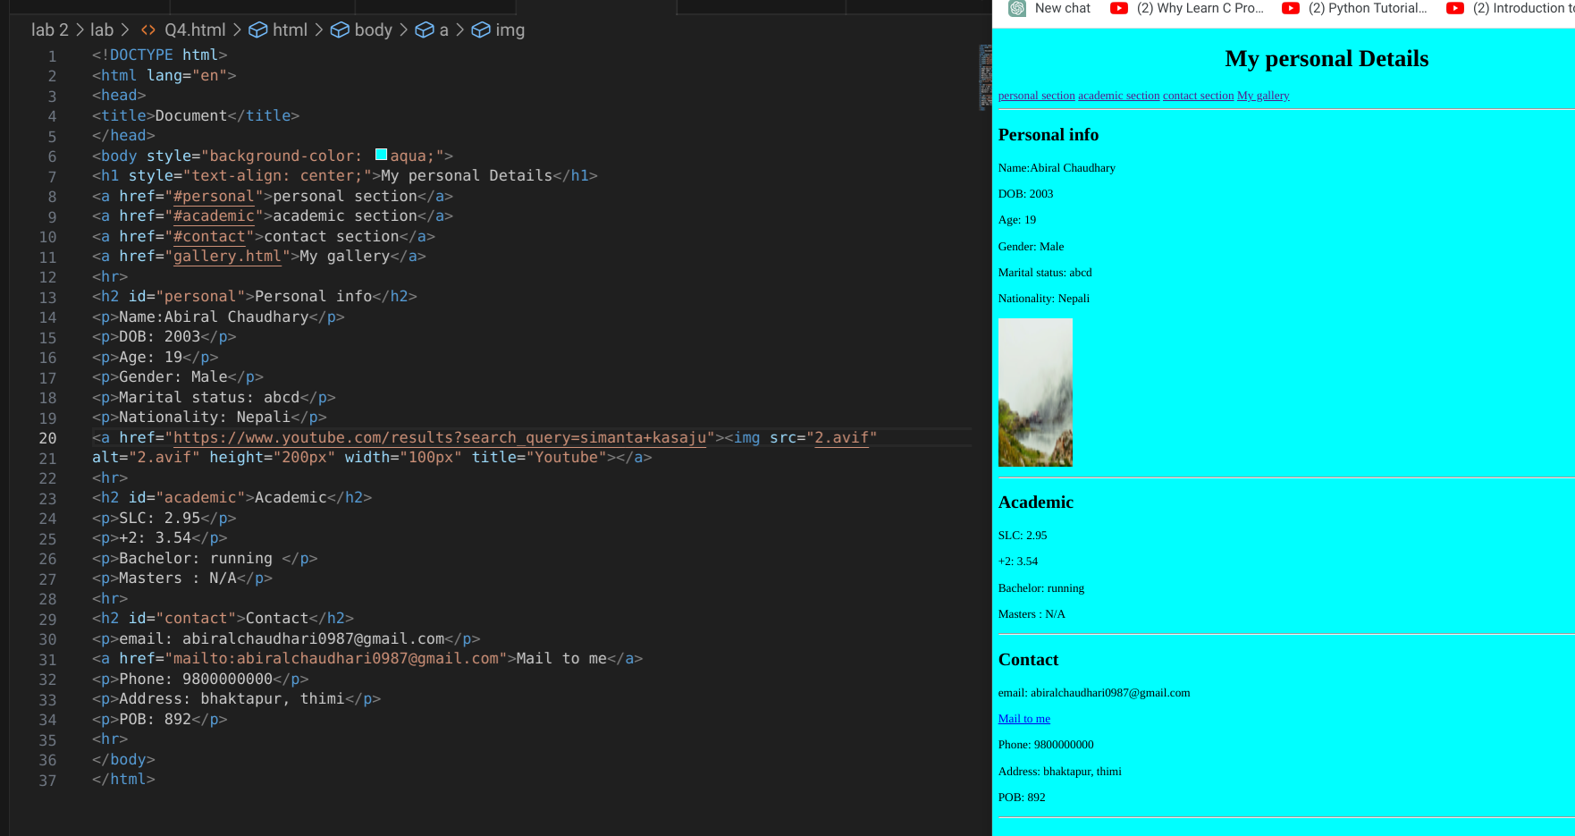

**Question :5**

**code:<!DOCTYPE html>**

**<html lang="en">**

**<head>**

**<title>Document</title>**

**</head>**

**<body>**

**<h1>This is homepage</h1>**

**<hr>**

**<a href="gallery.html">goto gallery section</a>**

**</body>**

**</html>**

**Screenshot:**

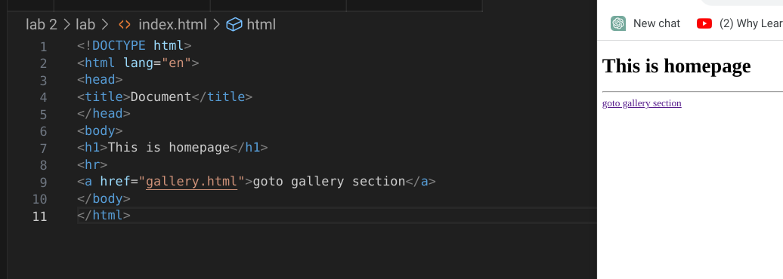

**Code:**

**<!DOCTYPE html>**

**<html lang="en">**

**<head>**

**<title>Document</title>**

**</head>**

**<body>**

**<h1>This is my gallery</h1>**

**<hr>**

**<img src="2.avif" alt="error loading" height="200px" width="100px">**

**<img src="2.avif" alt="error loading" height="200px" width="100px">**

**<img src="2.avif" alt="error loading" height="200px" width="100px">**

**<img src="2.avif" alt="error loading" height="200px" width="100px">**

**<img src="2.avif" alt="error loading" height="200px" width="100px">**

**<img src="2.avif" alt="error loading" height="200px" width="100px">**

**<a href="index.html">goto homepage</a>**

**</body>**

**</html>**

**Screenshot:**

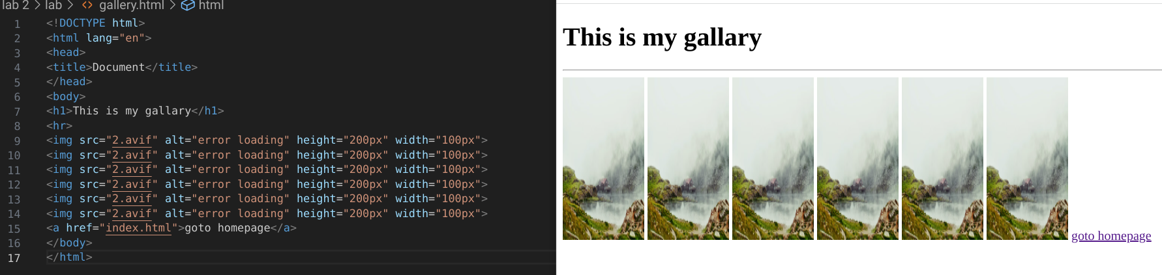

**Question:6**

**Code:<!DOCTYPE html>**

**<html lang="en">**

**<head>**

**<meta charset="UTF-8">**

**<meta http-equiv="X-UA-Compatible" content="IE=edge">**

**<meta name="viewport" content="width=device-width, initial-scale=1.0">**

**<title>Document</title>**

**</head>**

**<body>**

**<img src="1.png" alt="Error loading" height="500" width="400" title="lion">**

**<img src="3.png" alt="Error loading" height="400" width="500" title="Cr7">**

**<img src="2.avif" alt="Error loading" height="350" width="250" title="peacefull"><br>**

**<img src="4.png" alt="Error loading" height="350" width="550" title="Ms Dhoni">**

**<img src="2.png" alt="Error loading" height="300" width="550" title="tiger">**

**</body>**

**</html>**

**Screenshot:**

